

Q-Learning Management System
User manual

How to add a new Module
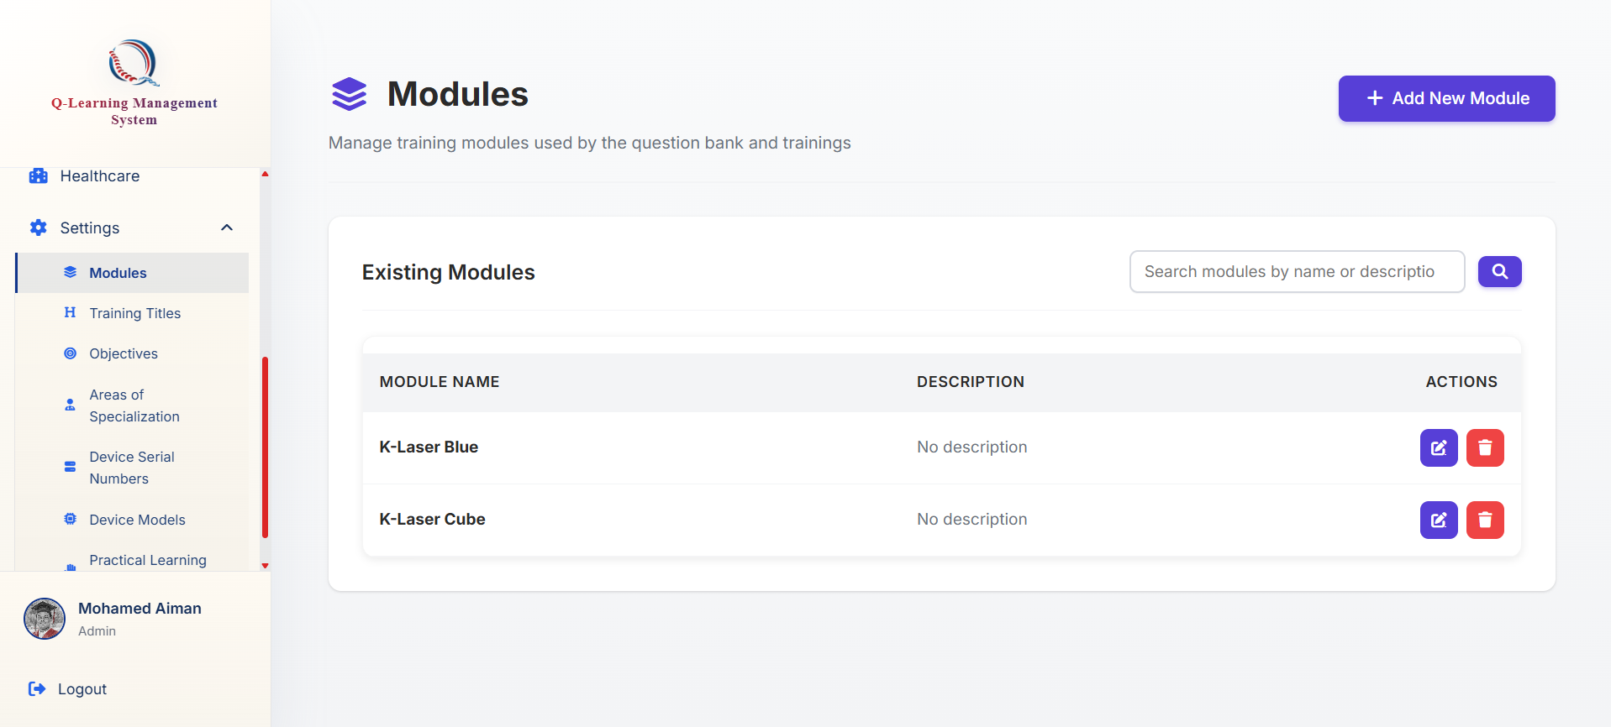
Click on the add Modules button

Go ahead to the Modules tab at the bottom of the sidebar
These modules will be used by the system when creating questions later in the question bank and will need to be defined when creating a training later.



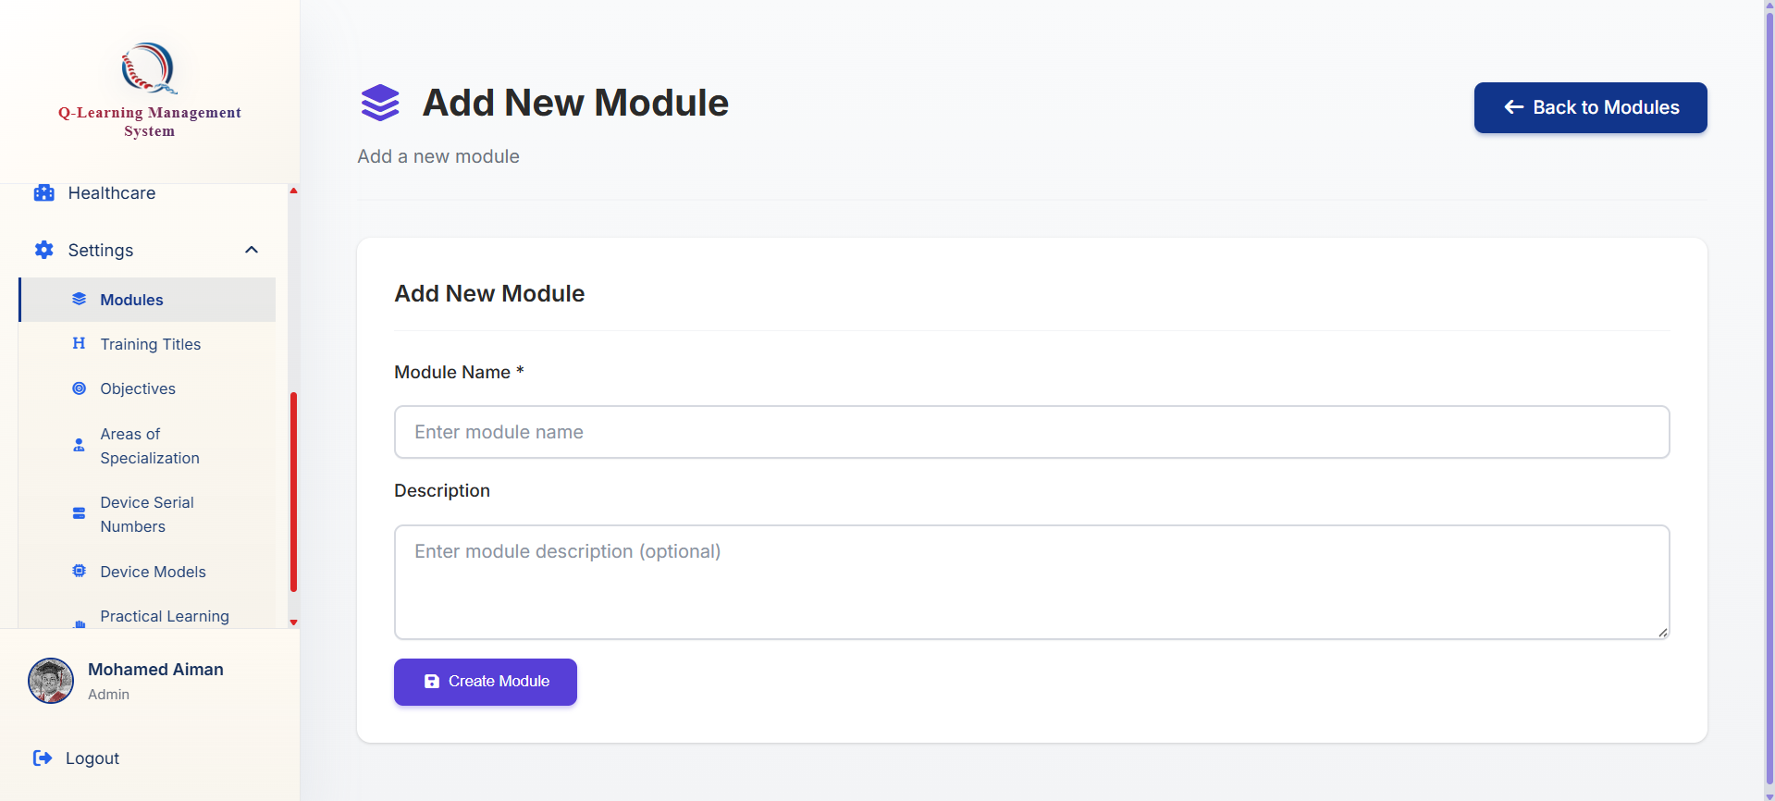
You will be brought to this form where you may fill up the details needed
Click on this button to submit and create

